Exp. No: 3 Determination and plotting of Force of attraction between two electric Charges and two parallel conductors separated by varying distance.
Date:
Aim:
To Determination and plotting of Force of attraction between two electric Charges and two parallel conductors separated by varying distance between them using SCILAB.

Software required:
- SCILAB version 6.0.1

Program/Output:
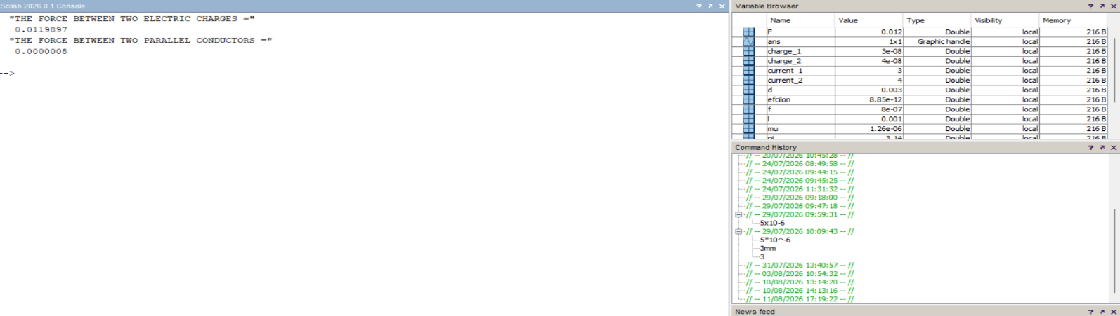
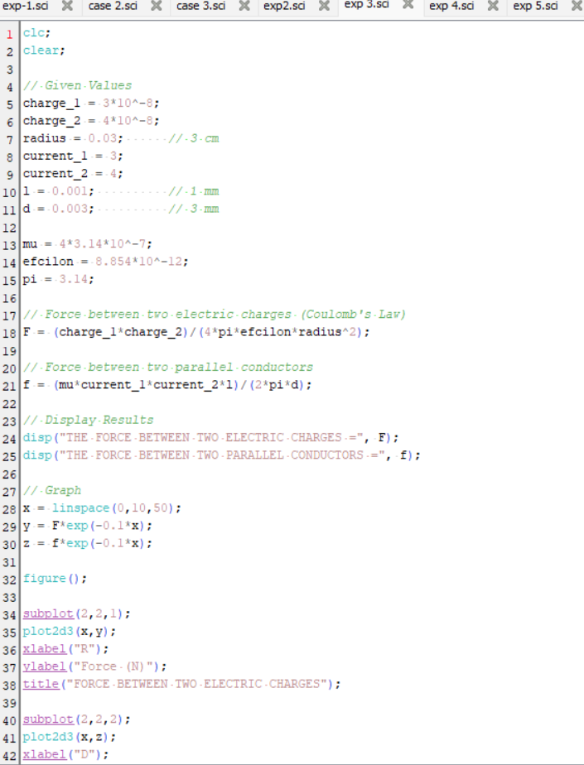
Calculation :
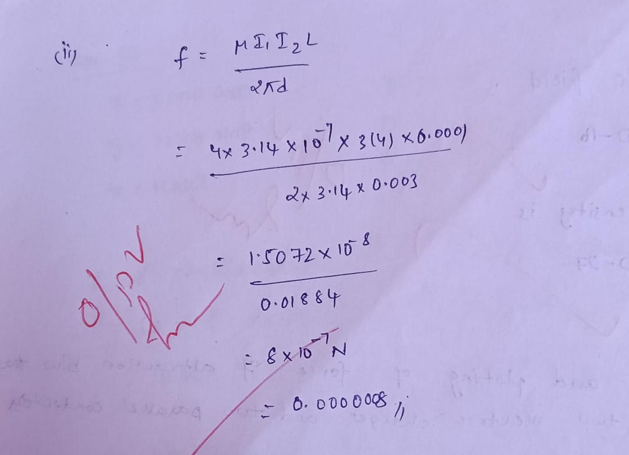
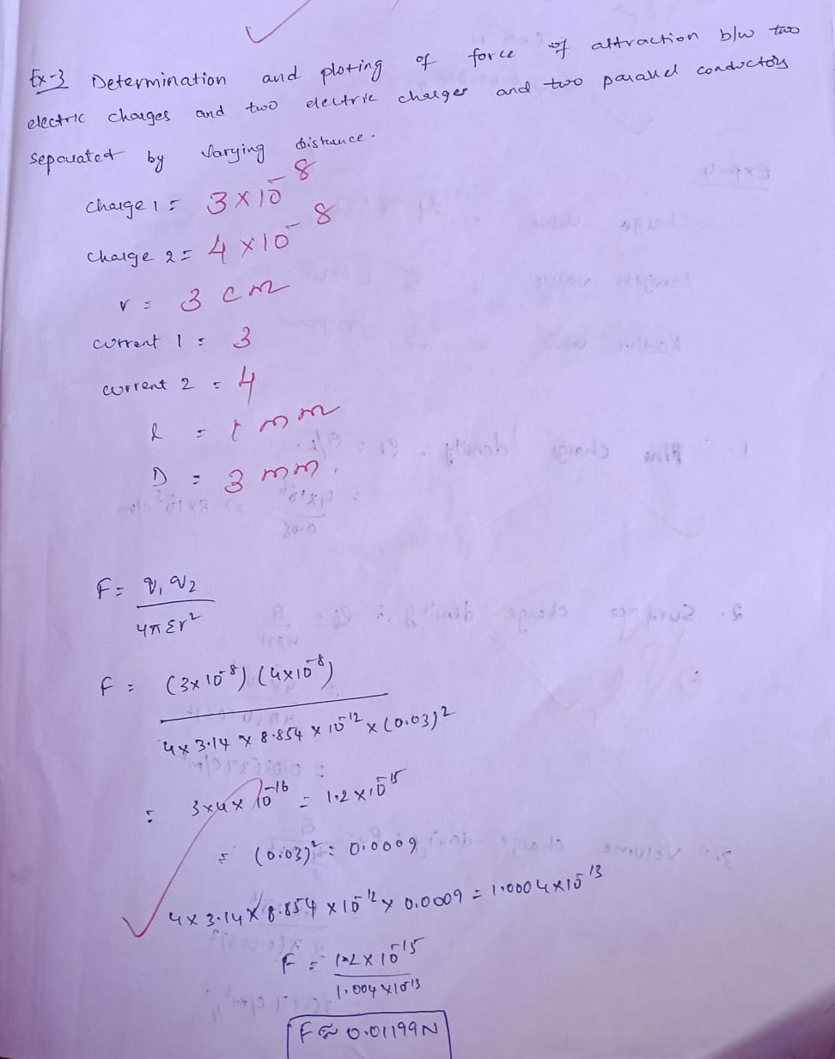

Result :
Thus the program was verified for the force of attraction or repulsion acting along a straight line between two electric charges is directly proportional to the product of the charges and inversely to the square of the distance between them using SCILAB was successfully.

